

Software Engineering Department

Braude - College of Engineering

Capstone Project Phase A – 61998

**Diagnosing early pediatric failure to thrive (FTT)**

**Project code:** 24-1-D-3

**Supervisor:**

Dr. Natali Levi-Soskin

**Authors:**

Sabeel Hamood - 211581343

[Sabeel.Hamood@e.braude.ac.il](mailto:Sabeel.Hamood@e.braude.ac.il)

Ehsan Sarboukh - 209002534

Ehsan.Sarboukh@e.braude.ac.il

**Abstract:**

Failure to thrive (FTT) is a common issue among infants, often overlooked or missed. Current diagnostic systems for FTT are outdated and rely on factors like weight or height below the 3rd percentile for age or a decrease in growth rate.

Our system, FTTell, diagnoses children who suffer from the FTT problem between 0-60 months of age, by entering details relevant to the diagnosis, if the patient is in the age range of 6-25 months, the system requires an additional test which relies on computer vision, decoding the photograph of the patient's facial expressions and his quantitative data undergo a more in-depth analysis with the help of research-proven formulas and the use of the AI-ChatGPT tool.

It displays the diagnosis result (suffering from FTT/healthy) and accordingly offers treatment for the problem.

The system is used by pediatricians as well as parents, but the data entered by parents is not saved in the database, meaning they use the demo system.

It improves early diagnosis and treatment, allowing healthcare professionals to develop individualized treatment plans and provide evidence-based recommendations. This helps in making informed decisions about diagnostic tests, treatment options, and referrals to specialists.

Table of Contents

**Abstract** 2

**1.** **Introduction** 5

**2.** **Review** **of the Literature** 7

**3.** **Expected achievements** 11

3.1 Outcomes11

3.2 Unique features 11

3.2.1 Data mining and Machine Learning 11

3.2.2 Comprehensive Data Base 11

3.2.3 User-Friendly interface 11

3.2.4 Continuous Improvement and Adaption11

3.3 Criteria for success 12

**4.** **Process** 13

4.1 Research: An in-depth study of the FTT problem 13

4.1.1 Constraints and Challenges 14

4.1.2 Conclusions from Research – Inspiration for Simulation 15

4.2 Research – Artificial intelligence API 16

4.2.1 Constraints and Challenges – Artificial Intelligence 16

4.3 Research – Computer Vision 18

4.3.1 Constraints and Challenges – Computer vision 19

4.4 Methodology and Development Process 20

**5.** **Product** 22

5.1 Requirements 22

5.2 Architecture overview 23

5.3 Web Application 26

5.3.1 Technologies for Frontend 26

5.3.2 Technologies for Backend 26

5.3.3 ChatGPT AI tool 26

5.3.4 Computer vision 27

5.4 User Interface 28

5.5 Diagrams 33

5.5.1 Use Case 33

5.5.2 Class 34

5.5.3 OPM 35

**6.** **Verification and Evaluation** 36

6.1 Evaluation 36

6.2 Verification 36

**7.** **References** 40

**1.****Introduction:**

Failure to thrive (FTT) is common among infants at young age, usually less than five. Therefore, there are standard quantitative definitions for diagnosing FTT, it is sometimes easily missed or not diagnosed on time.

There are two main types of FTT: organic and inorganic, when medical evaluations fail to identify organic causes for the growth failure, a diagnosis of nonorganic FTT is made [7][9].

Lack of diagnosis on time can have a negative effect on child's development process and normal growth. Therefore, there is a need to solve this problem, allowing accurate on time diagnosis.

According to the American Academy of Family Physicians, FTT is a common problem that can affect up to 10% of children in primary care and approximately 5% of children who are hospitalized. The prevalence of FTT is higher in developing countries, where it can affect up to 30% of children [4].

Nowadays there is no diagnostic systems that doctors can use as a decision support tool for diagnosing FTT. The diagnosis of FTT is based on a child's weight and height below the 3rd percentile for age or a progressive decrease in the rate of gain of height or weight, physical examination, and growth parameters documented over time. Targeted laboratory and other diagnostic testing may be necessary to identify underlying causes of FTT.

This indicates that the medical professionals still employ antiquated techniques, and that there isn't an intelligent system in place to identify the issue and offer suitable care for the child's condition.

We are currently in the planning phase for a system that aims to diagnose growth problems in children aged 0-60 months. Our approach will utilize Data Mining, Machine Learning algorithms and computer vision, analyzing a comprehensive database of children diagnosed with growth issues and healthy children. The algorithm will define criteria for identifying children with growth problems and those with normal development. Ultimately, it will generate an accurate diagnostic result and appropriate treatment.

This solution can improve the team's ability to assess and treat problems effectively at an early age, which can be essential in the treatment of disorders, they can have a comprehensive understanding of the child's health related to growth. This assists staff in developing individualized treatment plans for each child and providing evidence-based recommendations to healthcare professionals, therefore it helps in making decisions about accurate diagnostic tests, treatment options and referrals to specialists.

we will explore various topics critical to our research work before embarking on the planning and development phase. Section 1 will delve into a comprehensive literature review, examining articles and studies that will serve as the foundation for our planning. In Section 2, we’ll discuss expectations and goals, providing detailed insights into our intended direction. Section 3 will be divided into two main parts: first, we’ll describe and explain the engineering development process; second, we’ll present algorithms, models, data structures, and a glimpse of the user interface. Finally, in Section 4, we’ll outline our testing strategy for the program.

**2.** **Literature Review:**

Pediatric Failure to Thrive (FTT), also known as weight faltering poses a substantial challenge for pediatricians, often leading to delayed diagnosis [4].

FTT is defined by weight-for-age below the 3rd percentile or weight deceleration across two major growth chart percentiles, with single indicators having limited predictive values.

Pediatricians need to evaluate the child from several angles, including psychosocial development, prenatal, birth weight, and postnatal development, to identify FTT [7][9].

The differential diagnosis for failure to thrive is extensive, historically categorized as organic and nonorganic. Organic failure to thrive involves major disease processes or organ dysfunction, while nonorganic failure to thrive suggests insufficient emotional or physical nurturing without clear pathophysiologic abnormalities, often associated with reactive attachment disorder.

Researchers team found that prevalence varies based on the studied population and recognition criteria [4].

In the U.S., around 10% of children in primary care and 5% of hospitalized children may experience FTT. An analysis showed varying rates of children crossing major percentiles in height-for-age and weight-for-age across different age groups. Weight-for-height had the highest crossing rates during preschool years, while weight-for-age had the lowest [2].

However, a downward shift doesn't necessarily indicate failure to thrive; a research showed that nearly 30% of normal babies experience a downward shift between 3 and 18 months, with the average of 13 months [9].

Low birth weight is a major predictor of the need for future referral for failure to thrive refer to height-for-age, weight-for-age, weight-for-height, and BMI-for-age.Risk factors may be classified as psychosocial or medical [4].

psychosocial: economic factors, psychosocial status considerations include marital stress, potential homelessness, domestic violence, parental employment, and substance abuse. Children born to mothers under 18 show poorer growth, especially in the first year, and are twice as likely to experience neglect compared to those born to older mothers [9]. medical: inadequate caloric intake, Gastroesophageal reflux, Inadequate breast milk supply, or ineffective latching, incorrect formula preparation, Mechanical feeding difficulties (e.g., cleft lip or palate) etc. [4].

FTT should be considered a clinical observation rather than a diagnosis. Nowadays recognition relies on consistent and accurate measurements of weight and height over time, Head circumference (HC), documented on appropriate growth charts that use the "WHO charts (http://www.who.int/childgrowth, http://www.cdc.gov/growthcharts)". [4], when growth problems are suspected in infants, a team of doctors may recommend various laboratory tests to investigate further. These tests typically include: Blood count, Urinalysis, Electrolyte measurement, Thyroid function tests, Celiac disease testing, Testing for food allergies[4].

When medical evaluations fail to identify organic causes for the growth failure, a diagnosis of nonorganic FTT is made [1].

Facial recognition and emotional expressivity play vital roles in infants' social and cognitive development. Nonorganic FTT infants' facial expressions offer insights into their emotional display [1].

Currently, the "Rourke Baby Record" (RBR) from Canada is a comprehensive tool used for monitoring growth, although it is not employed for diagnosing FTT [8].  
In modern diagnostic approaches, computer vision is being incorporated into pediatric healthcare through facial recognition, aiding in the identification and tracking of children. This integration enhances tailored care and boosts administrative efficiency within the medical sector. Furthermore, while AI tools can offer insights based on symptoms to assist in diagnosing Failure to Thrive (FTT) in children, they are not typically used by physicians for making medical diagnoses.

FTTell, a model-based tool for diagnosing postnatal FTT in children aged 0–5, has received ethical approval "permission number 0665-19-RMB". With a user-friendly interface and continuous updates, it achieved 87% accuracy in diagnosing FTT in 100 infants compared to expert diagnoses. Medical professionals can contribute to its refinement, aiding in accurate FTT diagnoses by pediatricians. This model is built on OPM models, prioritizing efficiency, and user-centric design. This approach ensures iterative improvement and optimal system performance [7].

To investigate the relationship between the facial expressions of children with non-organic FTT, the study included 12 nonorganic FTT infants (ages 6 to 25 months) and 12 matched control infants, they were videotaped in social and cognitive contexts to capture their facial expressions and emotional responses [1].

1. The first segment, lasting 4 minutes, was taken from an interview with the mother. During this time, the infant sat on the mother's lap with a few toys on a table in front, providing a relaxed environment for potential emotion expression.
2. The second segment comprised the first 3 minutes of administering the Bayley Scales of Infant Development, to reflect the infant's functional level.
   1. In the third segment of the testing procedure, the infant first engaged in a 1.5-minute face-to-face interaction with the experimenter.
   2. Following this, there was a 1.5-minute presentation of three toys - a mask, a jack-in-the-box, and balloon noise - selected to provoke emotional responses in the infant.
3. This was followed by a 2-minute face-to-face interaction between the infant and the mother, In the last dyadic interaction segment, mothers were given instructions to engage with their infants in a manner similar to how they would typically play with them at home.

To maintain consistency in infants' experiences, they first interacted with the experimenter, followed by their mothers, with an emotion-eliciting toy segment in between. Various age-appropriate toys were used to evoke emotions. Facial expressions were coded using the MAX system by Izard (1979), which categorizes emotion-relevant facial movements into upper, middle, and lower face actions [1].

FTT infants showed fewer expressions of positive emotions like joy, interest, and surprise compared to typically developing infants. In contrast, FTT infants displayed a higher frequency of negative emotions, including fear, sadness, anger, disgust, and displeasure. Furthermore, these negative emotional expressions lasted longer in FTT infants than in controls [1].

In addition to facial movements, this study also coded three other behaviors related to the regulation of emotional states: eye gaze, and self-comforting gestures. Four types of gazes were coded: averted attention, gazes toward the task, gazes toward the mother, and gazes toward the experimenter. Self-comforting behaviors encompassed actions such as playing with the hands, bringing the hands to the mouth or head, and placing objects in the mouth [1].

Results indicated that FTT infants exhibited a significantly higher frequency of expressions involving the lower face compared to controls. Conversely, the use of the upper face did not significantly differ between the two groups, FTT infants averted their gaze (from the toy or from the experimenter) more often than controls [1].

Treatment is given according to the source of the problem (medical or psychosocial)

Pharmacotherapy like cyproheptadine or megestrol (Megace) may be used for severe cases with underlying diseases or cancer treatment but isn't generally recommended for FTT. Catch-up growth involves children gaining at two to three times the average rate for their age, with adjustments to breastfeeding or formula advised for infants with inadequate caloric intake [4].

Facial recognition in nonorganic FTT infants can provide clues about the environment of the infant and which can indicate the development of FTT following an environmental rather than genetic factor [1].

Psychosocial interventions include counseling parents on sick care management and promoting a balanced diet. Home nursing visits can supplement clinic evaluations, especially for families with transportation or work-related issues. Families experiencing food insecurity should receive social work support or access community resources like the Women, Infants, and Children program [4].

**3.****Expected achievements:**

**3.1. Outcomes:**

The outcome we expect is to develop an innovative system for the early diagnosis and treatment of growth problems in children aged 0-60 months. The system will offer healthcare professionals a reliable decision support tool to accurately identify children at risk of failure to thrive (FTT) and provide personalized treatment plans based on evidence-based recommendations, furthermore, it will generate a growth chart for the treated child, which is used to determine whether to diagnose the child with FTT.

**3.2 Unique features:**

3.2.1 Data mining and Machine Learning:

The development will be based on sophisticated data mining and machine learning algorithms. To determine whether the kid is among those who have been diagnosed with FTT disease, as well as the severity of the condition and recommend an appropriate course of therapy, it will compare the patient data with its data collection.

3.2.2 Comprehensive Data Base:

Another key feature of our system is the utilization of a comprehensive database comprising information on children from age 0-60 months (diagnosed with FTT/not diagnosed) . The accuracy and reliability of our system depends on the quality and the quantity of the data that exists in our database.

3.2.3 User-Friendly interface:

Our system will be a web application with many user-friendly interface features designed to facilitate and streamline the diagnostic process and enable seamless interaction with healthcare professionals. The interface will provide feedback in real time. In addition, the availability of the system 24/7, providing services on an ongoing basis to the medical team. The data in the system is secure, access is not restricted to all people, only people with limited privileges.

3.2.3 Continuios Improvement and Adaption:

We recognize that pediatric healthcare is a dynamic and evolving field, requiring continuous improvement and adaptation of diagnostic tools and practices. Therefore, our system will feature built-in mechanisms for ongoing evaluation, feedback, and refinement based on real-world usage and stakeholder input. By embracing a culture of continuous improvement, we aim to ensure that our system remains at the forefront of pediatric diagnostic innovation, delivering optimal outcomes for children and families.

**3.3 Criteria for success:**

1. Accurate Diagnosis: The system should accurately identify children with growth problems and differentiate them from healthy controls.

2. Timely Intervention: The system should optimize the process of early diagnosis.

3. Evidence-Based Recommendations: The system should provide healthcare professionals with evidence-based recommendations for diagnostic tests, treatment options, and specialist referrals.

4. User satisfaction (medical professionals): The system should be user-friendly, intuitive, and seamlessly integrated into existing clinical workflows, while improving user satisfaction.

5. Continuous improvement: The system should include mechanisms for continuous evaluation, feedback, and refinement to ensure continuous improvement and adaptation to evolving clinical needs.

6. Patient outcomes: The system should ultimately improve patient outcomes through early diagnosis, individualized treatment, and evidence-based decision-making on child development issues.

**4.** **Process:**

* 1. Research: An in-depth study of the FTT problem.

For our project aimed at developing a tool for diagnosing FTT in children, we focused on the following questions:

-What is FTT?

- What signs and symptoms of FTT are present in children, and how is it diagnosed by a pediatrician?

- Which age range does the child's FTT symptoms start to show up in, and how many tests should the doctor do for having an accurate FTT diagnosis?

- which kinds of treatment may help an FTT diagnosed child?

- If a patient with FTT had mild symptoms, might pediatrics overlook the diagnosing the FTT?

- What are some key differences in facial expressivity between failure to thrive infants and normal infants?

- How does facial expressivity impact the socialization and emotional development of infants?

- What kinds of tools aren't dependent on technology, and how trustworthy and applicable are they in the modern world?

- How does FTT impact growth and development milestones in children aged 0-60 months?

- What are the socio-economic factors that may contribute to the prevalence of FTT among infants and young children?

- What interventions and treatments are most effective in addressing FTT in this age group?

- How does FTT prevalence and presentation differ among different ethnic or racial groups?

We used a variety of resources, including articles and scientific papers, to address these issues and to confront these questions. We convened following our reviewing of the available materials to exchange our conclusions and identify the primary areas of emphasis for the application's development.

After conducting an extensive review of the available information, we gathered to discuss our findings and delineate crucial factors to consider in the development of the diagnostic tool, furthermore children ages 0 to 5 should be the primary target age range.

We have reached critical conclusions for the success of our development for an early diagnosis for FTT, in order to be accurate in the diagnosis result, it is necessary to check beyond the child's weight and height, other factors such as Head circumference (HC), Mechanical feeding difficulties, Chronic gastrointestinal conditions, allergies, genetical factors (weight and height of the parents), facial recognition.

* + 1. Constraints and Challenges:

Up to this point, we have encountered several obstacles in the process of creating this project. One of the main challenges was defining the data set we would rely on. It also determined what symptoms to look for to accurately diagnose FTT in children, how reliable it would be for the pediatrician to decide whether to tell the parents if their child has the condition or not. We had to use creative thinking to come up with a way to build a web application that will diagnose illnesses quickly, accurately, and without errors.

Further, we should think about the primary symptoms to identify FTT in children and what type of appropriate therapy our app should provide.

Which user types are allowed to use the app, add data to our database, and access it? Additionally, which AI should be used to compare the results of the precise diagnosis with our algorithm based on formula to determine each child's BMI.

Moreover, the only way to check the face expressions of the child by the use of computer vision face recognition, the challenges come by understanding the implementing of the algorithms of the computer vision.

4.1.2 Conclusions from Research – Inspiration for Simulation

After an in-depth reading of the articles, we concluded some insights that helped us to cope with the challenges and obstacles we discovered during the research work, one of the main conclusions concerns the definition of the database, we concluded that it is very important to determine a final database and it must contain more than the child's weight and height( calculation BMI), also we need to check elements related to genetics and the child's environment, we have found out that the face recognition reflects the child's psychosocial condition which can provide us with information about the child's environment, additionally, we will check Head circumference (HC), allergic(type 3), genetical factors (weight and height of the parents).

In addition , we found that there is no technological tool that exists today for an accurate diagnosis of the FTT problem in children, but there is a tool "the Rourke Baby Record" that establishes a baseline for ongoing monitoring, particularly considering the impact of severe nutritional compromise, it provides general monitoring of the child's condition, but does not provide a diagnosis for FTT problems.

Moreover, this tool will not be available to all doctors in the world but only in Canada, therefore there is a need to develop a system for accurate diagnosis of FTT problems in children.

Furthermore, we discovered that this problem could appear not only in babies but also in children over 5 years old. Nevertheless, we will focus on children aged 0-60 months. Considering the fact that facial recognition addresses children between age 6 – 25 months due to that the computer vision is done for this age range.

**4.2 Research – Artificial intelligence API :**

Before being able to explain how artificial intelligence works, one must first gain an understanding of many different aspects of the rapidly developing field of artificial intelligence. This includes knowing the fundamentals of symptoms in order to diagnose FTT in children and comparing them to calculations made by our algorithmic formulas. Among the key topics we had to discuss were:

**Software**:

* Which tools are available right now.
* How the tool is being injected into our development.
* Enhancement of performance.
* comparison with the outcome of our formula-based approach.
* supplying an appropriate course of therapy and a trustworthy FTT diagnosis.

4.2.1 Constraints and Challenges – Artificial Intelligence:

Integrating an AI tool into our web development application for diagnosing Failure to Thrive (FTT) in children is a commendable initiative. However, it’s essential to be aware of the constraints and challenges we might encounter. Here are the key points to consider:

**Algorithm Bias:**

AI models learn from historical data, which may contain biases. If the training data is skewed or lacks diversity, the AI tool could perpetuate these biases, affecting diagnosis accuracy.

Ensure rigorous data preprocessing and validation to minimize bias.

**Data Quality and Availability:**

High-quality data is crucial for accurate diagnosis. In healthcare, data can be incomplete, inconsistent, or noisy.

Considering data augmentation techniques and collaborating with healthcare providers to improve data quality.

**Interpretability and Explainability:**

AI models often function as black boxes, making it challenging to understand their reasoning.

Develop methods to interpret model predictions and provide explanations to clinicians and patients.

**Clinical Validation and Trust:**

Clinicians may be skeptical of AI-based diagnoses. Conduct rigorous clinical validation studies to demonstrate the tool’s reliability.

Build trust by involving healthcare professionals in the development process and emphasizing transparency.

**Integration with Existing Systems:**

Integrating the AI tool seamlessly into our web application requires compatibility with existing infrastructure.

Ensure smooth data flow between the AI module and other components.

**Scalability and Performance:**

As user demand grows, the AI tool must handle increased traffic efficiently.

Optimizing algorithms for speed and resource utilization.

**User Experience and Adoption:**

Designing an intuitive user interface for clinicians to interact with the tool.

Train healthcare professionals in using the AI system effectively.

**Long-Term Maintenance and Updates:**

AI models require continuous monitoring, retraining, and updates.

Plan for long-term maintenance to ensure the tool remains accurate and up to date.

**4.3 Research – Computer Vision:**

In order to take advantage of the facial expressions that characterize children with FTT, we decided to use computer vision.

Computer vision is a field of artificial intelligence (AI) that empowers machines to interpret and understand visual information from the world, akin to human vision. It involves the development of algorithms and systems that enable computers to gain insights from images, videos, and other visual data, making sense of the visual world in a manner analogous to human perception.

Using Computer Vision for FTT Diagnosis in Children:

1. Facial Expression Recognition:

By leveraging computer vision, we aim to recognize specific facial expressions associated with children diagnosed with Failure to Thrive. This can provide valuable insights into their emotional well-being and potentially aid in early diagnosis.

2. Data Collection and Analysis:

Visual data, such as images or videos of children's faces, will be collected and analyzed using computer vision algorithms. The focus will be on extracting relevant facial features indicative of FTT-related expressions.

3. Machine Learning Models:

Machine learning models, particularly those in the realm of deep learning, will be trained to identify and interpret facial expressions linked to FTT. The system will learn patterns and correlations between facial cues and health conditions.

4. Real-time Monitoring:

Computer vision can enable real-time monitoring of children's facial expressions, allowing for continuous assessment and early intervention if signs of FTT are detected.

4.3.1 Constraints and Challenges – Computer vision:

Implementing a computer vision facial recognition system, especially in a healthcare context, comes with several challenges and constraints that must be carefully addressed. Here are some key considerations:

**Accuracy and Reliability:**

Challenge: Achieving high accuracy in facial recognition, especially for subtle expressions associated with health conditions like Failure to Thrive (FTT), can be challenging.

Constraint: Inaccuracy or misinterpretation of facial expressions may lead to false positives or negatives, impacting the reliability of the system.

**Diversity in Facial Expressions:**

Challenge: Children, especially infants, exhibit diverse and rapidly changing facial expressions. Developing a system that can accurately interpret this variability poses a significant challenge.

Constraint: Ensuring the system's robustness across different age groups, ethnicities, and emotional states requires careful consideration.

**Hardware and Infrastructure Requirements:**

Challenge: Implementing a facial recognition system may require specialized hardware for real-time processing, which can be resource intensive.

Constraint: Limited computational resources or access to high-performance hardware may constrain the system's efficiency and responsiveness.

**Data Quality and Quantity:**

Challenge: Training robust facial recognition models necessitates large, diverse datasets. Availability and quality of such datasets can be a challenge.

Constraint: Limited access to relevant, annotated data may hinder the training and performance of the facial recognition system, especially for specific health-related expressions.

**Real-Time Monitoring:**

Challenge: Implementing real-time monitoring of facial expressions for timely intervention is challenging due to latency constraints and the need for swift response.

Constraint: Achieving low latency while maintaining accuracy in real-world scenarios may be limited by technological constraints.

**User Acceptance and Trust:**

Challenge: Gaining user acceptance, especially from parents and caregivers, requires building trust in the system's capabilities and ensuring clear communication about its purpose.

Constraint: Overcoming skepticism or concerns about the reliability and intentions of the facial recognition system.

**Continuous Adaptation and Learning:**

Challenge: Facial expressions associated with FTT may evolve over time. The system needs to adapt and learn continuously to remain effective.

Constraint: Developing mechanisms for continuous learning and adaptation within the system architecture can be complex and resource intensive.

* 1. **Methodology and Development Process:**

We decided to employ the Agile technique for development since we believe it best suits our use case. We will be able to divide our feature delivery into manageable chunks with the most adaptability for modifications by employing an iterative approach. We're going to divide up development into:

1. Defining Data set.
2. Building the database.
3. Running some of the data through several different AI tools.
4. Choosing an artificial intelligence tool to use in the project.
5. Requirements (functional, nonfunctional).
6. UML (use case, class, OPM) diagrams.
7. planning the user interface (front end prototype).
8. Injection an API of an AI.
9. Implementation of computer vision facial recognition algorithms.
10. Performing simulations on the database using the formulas of the algorithm.
11. Testing the accuracy of the algorithm in comparison with artificial intelligence tools.
12. Build the backend.
13. Building a friendly user interface.
14. Testing again after finishing the front and backend development.
15. Final project with UI UX design and platforms we are going to use.

We will ensure two weekly meetings to synchronize our strategies. Each meeting will focus on refining upcoming goals. Work will be segmented into iterations, with each iteration dedicated to accomplishing specific sub-tasks. After each iteration, we'll evaluate our progress thoroughly. Before commencing a new iteration, we'll address any issues and conduct a comprehensive review of existing implementations.

**5.** **Product**

**5.1 Requirements:**

Functional**:**

1. The system shall have a dedicated web-based app.
2. The system allows the user to insert new data.
3. The system stores data in a database.
4. The system shows the analysis of the result in real time.
5. The system displays the analysis in the web application.
6. The system can be used from any location with Wi-Fi access.
7. The system allows the usage of the camera for diagnosing (Computer Vision).
8. The systems display a guidance tutorial.
9. The system gives permission to authorized users to login (Pediatrics).
10. The system offers a suitable treatment.

**Nonfunctional:**

1. Easy to use user friendly interface.
2. Simple interaction mechanism.
3. Real time analysis.
4. Data are secure very well.
5. Application works 24/7

**5.2 Architecture overview:**

The architecture in our web development application is 3-tier architecture:

1. Client side: Sends a http request that reaches the presentation layer (frontend).
2. The business layer gets requests from the presentation layer and contains all the functionality in the presentation layer. (backend).
3. The business layer is fetched from the presentation layer and forward to the data layer.
4. The data layer sends requests for the server (MongoDB) and receives a reply accordingly.
5. The data layer sends data to the AI tool (Third party services) and receives a reply accordingly.

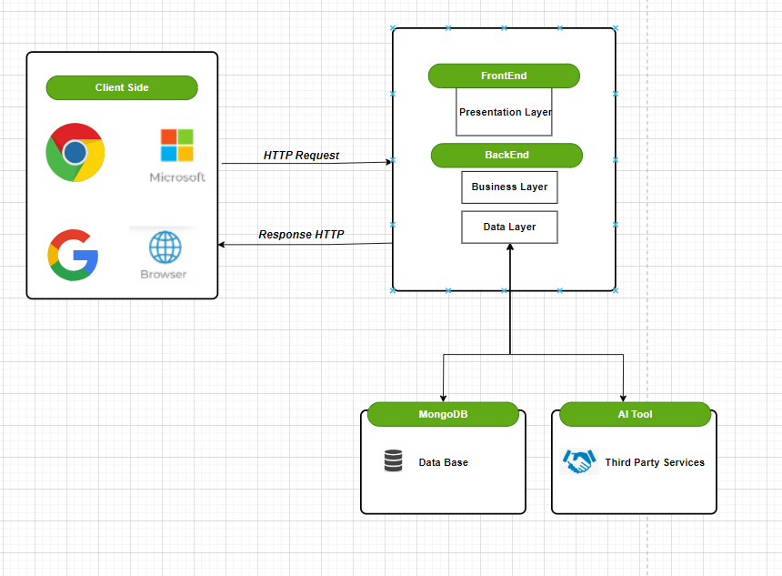

Figure 1: Architecture scheme

**Web Application:**

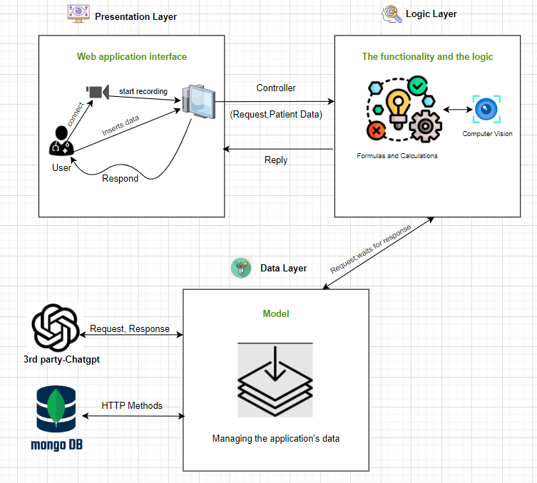

Figure 2: MVC Architecture

We opted for the MVC architectural design pattern, given that our system is structured into three layers. MVC is recognized for its ability to manage these three layers effectively, which are the presentation layer, data layer, and business layer.

Presentation layer (view):

The presentation layer (also known as the view) is responsible for displaying user interfaces, forms, and integrating camera functionality. When a pediatrician accesses the system, they input patient data, and after entering all required information, they submit it. The system then creates a patient record. The presentation layer ensures a smooth interaction between users and the application.

Business layer:

The **controller** retrieves data from the form and queries the **model**.

The **model** houses the entire logic and functionality of the web application.

The received data is processed using the implemented functionality.

Additionally, the business layer communicates with the data layer to obtain responses from the AI tool or database.

**The data layer** receives requests from the business layer and stores the data in the MongoDB database.

It also communicates with third-party services, including the AI tool.

The AI tool’s response is relayed back to the data layer, which then forwards it to the business layer.

In the business layer, a comparison is made between results from formulas and the AI tool, and the controller responds accordingly.

Finally, the controller presents the model’s reply that the view layer requested from the controller, The view layer presents on the screen for the pediatrician.

**Data storage and handling:**

After the doctor entered the patient's data, a new document was created in the database for the patient. Our web application, after processing the new data and diagnosing the child, will update the diagnosis result in our database, which will be stored in MongoDB.

This will give us easy access to the database from anywhere with an internet connection. The database will communicate with our web application which will use this data to categorize and present it as an analysis to diagnose FTT disease.

**5.3 Web Application:**

5.3.1 Technologies for Frontend:

**React.js** is an ideal frontend technology for developing a web application dedicated to diagnosing Failure to Thrive (FTT) illness in children aged 0 to 5 years. With its component-based architecture, React allows for the creation of modular and reusable user interface elements, facilitating the construction of an intuitive and interactive user experience. React's virtual DOM ensures efficient updates and rendering, crucial for real-time interactions in a diagnostic tool. Additionally, React seamlessly integrates with backend technologies like Node.js and Express, enabling smooth communication between the frontend and the server. This combination provides a responsive and dynamic interface for users, allowing them to input and retrieve information related to FTT diagnosis effortlessly. React's focus on a declarative and efficient approach to building user interfaces aligns well with the goal of creating a user-friendly and impactful frontend for a web application addressing the critical healthcare issue of FTT in young children.

5.3.2 Technologies for Backend:

**Node.js and Express** create a powerful back-end stack for developing a web application that aims to diagnose Failure to Thrive (FTT) in children aged 0 to 5 years. Leverage Node.js for a server-side JavaScript runtime and Express to develop an efficient API, with the ability to easily manage data, interact with MongoDB databases, and handle communication between the frontend and backend. This stack offers a fast, event-driven architecture that supports real-time updates and seamless user interactions. Express simplifies routing, while Node.js supports asynchronous operations to efficiently handle concurrent requests. With these technologies, we can focus on implementing FTT diagnostic logic, user authentication, and data security, while ensuring a responsive and scalable backend for our medical diagnostic application.

5.3.3 ChatGPT AI tool:

Incorporating ChatGPT into the web application designed for diagnosing Failure to Thrive (FTT) illness in children aged 0 to 5 years provides an innovative and personalized dimension to the diagnostic process. ChatGPT can intelligently analyze the input data and suggest suitable diagnostic considerations based on established medical knowledge. Furthermore, by integrating treatment guidelines into the system, ChatGPT can offer personalized and context-aware recommendations for addressing FTT, contributing to a more comprehensive and user-friendly diagnostic experience. This AI-powered feature enhances the application's capability to provide valuable insights and guidance, ensuring a more informed and supportive approach to tackling FTT in young children.

5.3.4 Computer vision:

Implementing computer vision, particularly facial recognition, in the web application designed for diagnosing Failure to Thrive (FTT) illness in children aged 0 to 5 years offers a cutting-edge and holistic approach to healthcare. By utilizing facial recognition technology, the system can capture and analyze subtle facial features and expressions, aiding in the assessment of potential signs of FTT. This innovative approach enhances the diagnostic process by providing an additional layer of information, such as changes in facial appearance or expressions that may indicate underlying health issues. The computer vision system can contribute valuable insights into the child's well-being, complementing traditional diagnostic methods. Moreover, the integration of facial recognition allows for the creation of a more personalized and visually intuitive user interface, improving the overall user experience for both caregivers and medical professionals involved in the diagnosis and treatment of FTT in young children.

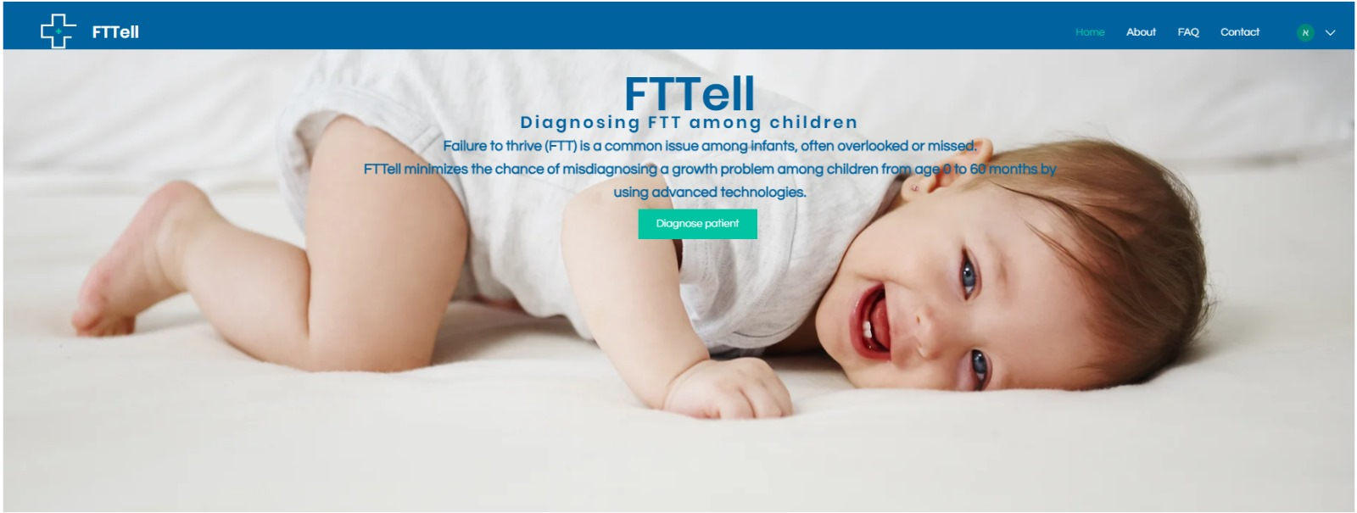**5.4 User Interface:**

Figure 3: Home page

The home page is simple, does not contain many elements, which makes it easier for the pediatrician to comfortably browse the website.

By clicking on “diagnose patient”, the pediatrician will be taken to the login screen; if he/she is not connected to the system, he/she will be taken to the window for entering the patient's ID.



Figure 4: Step 1 in diagnosing FTT

The pediatrician must insert the identification number of the patient and click apply, to start the diagnosing procedure.

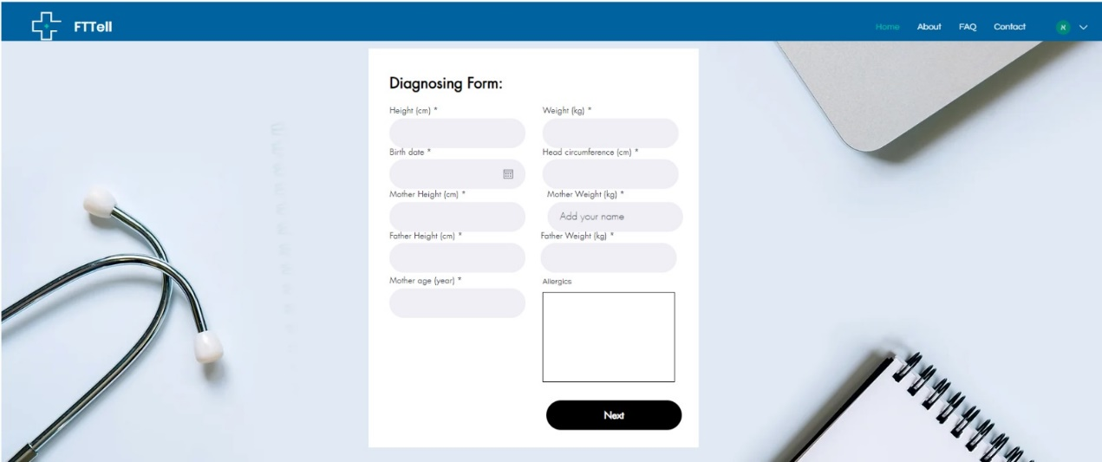

Figure 5: Step 3 in diagnosing FTT

The pediatrician inserts the information in the required fields. If the age of the patient is between 6 to 25 months the next button appears.

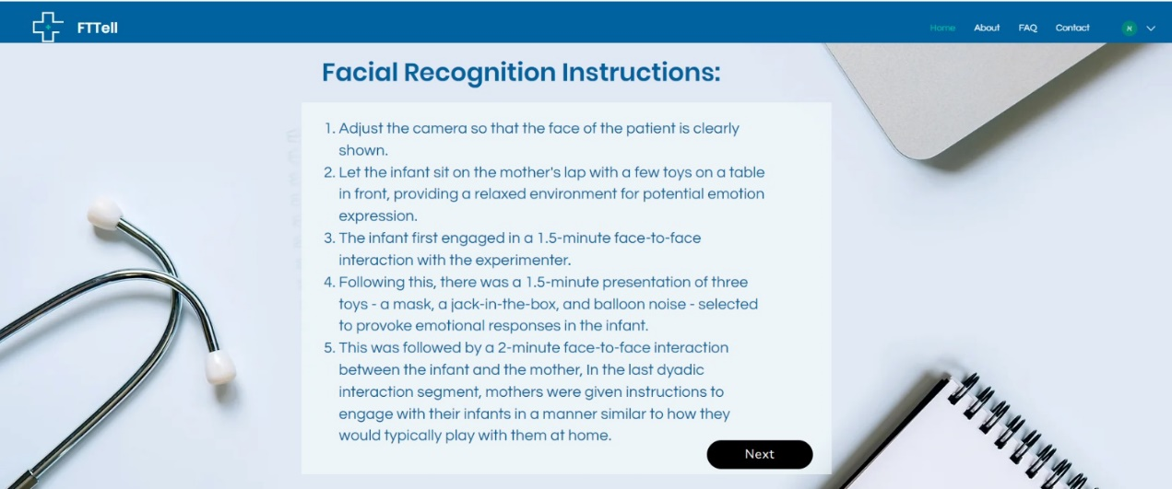

Figure 6: Step 3 in diagnosing

Figure 7: Step 3.1 in diagnosing FTT

This window addresses children between the age 6 to 25 months.

The pediatrician, after adjusting the camera, must press on the recording icon in the middle of the page and make a recording of the patient’s face.

After that click on apply.

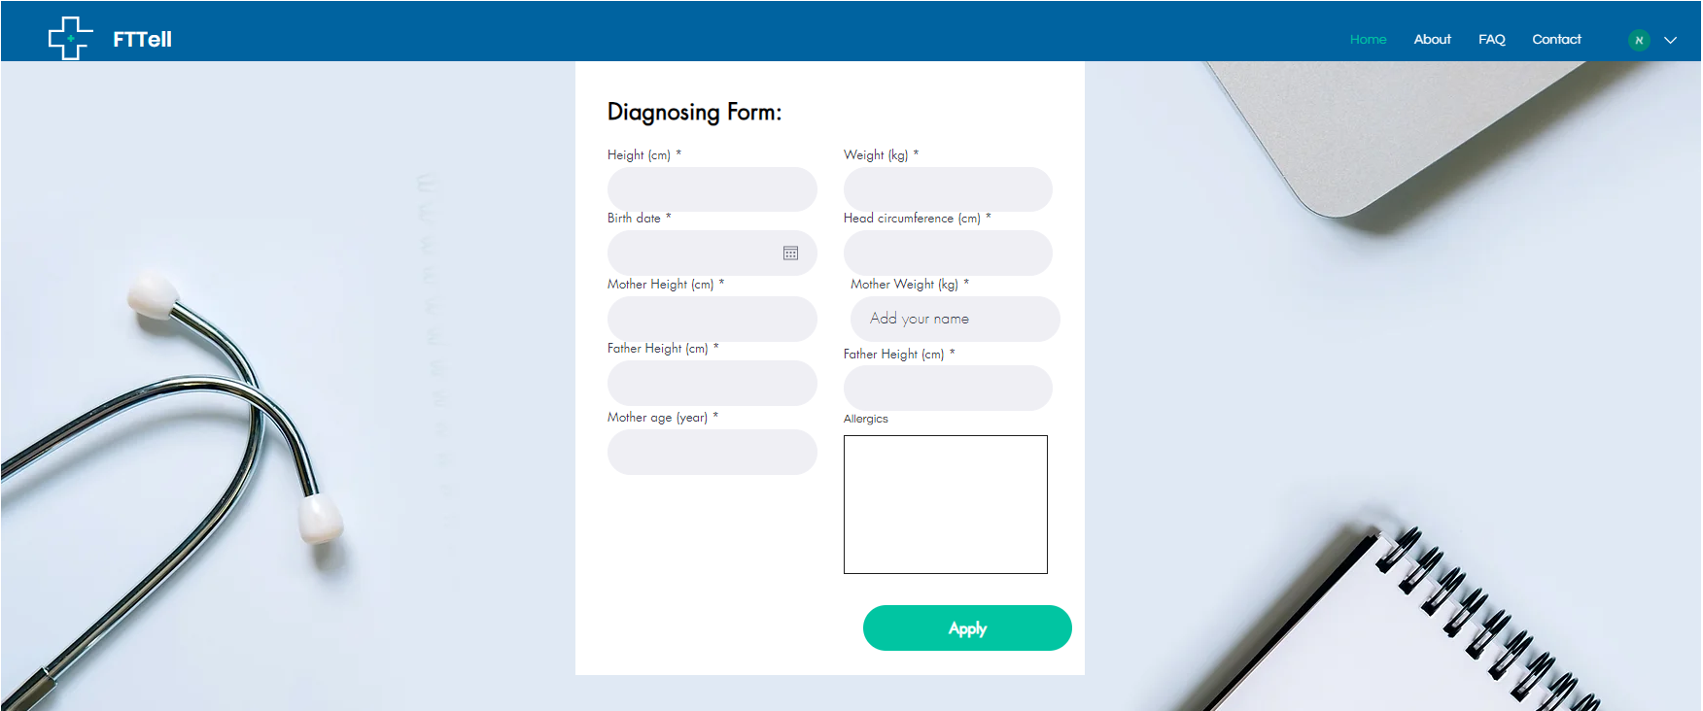

Figure 8: Step 3 in diagnosing FTT

If a user clicks on the Demo Diagnose button, he is transferred to this window and enters the child's data, but this data will not be added to the database.

In addition, if the pediatrician connects to the system and begins with a diagnosis, he is also transferred to this window, but the difference is that the data is saved in the database.

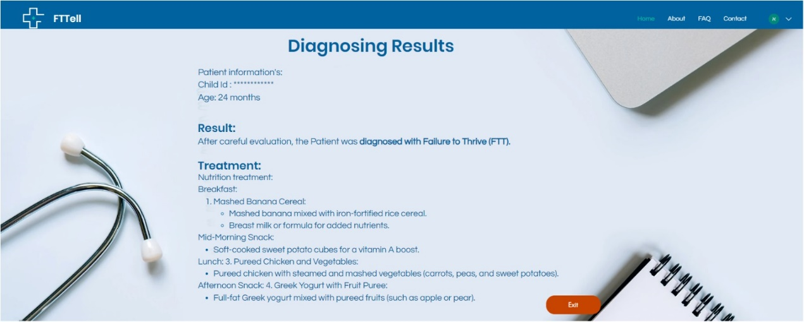

Figure 9: Result

The patient information is passed through multiple testing and comparison with ai results.

The results will be shown to the pediatrician on the screen with suitable treatment.

Click on the exit button will return to the home page.

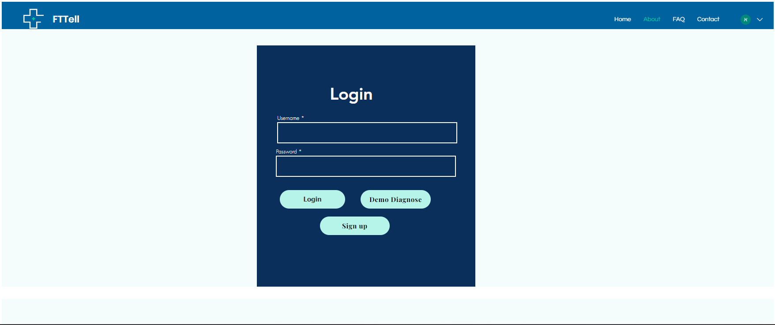

Figure 10: Login Page

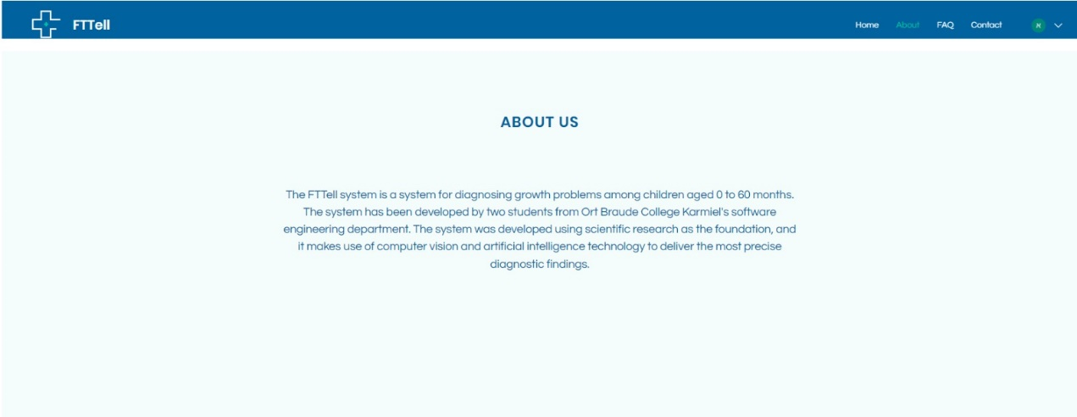The authentication is approved only for pediatrician’s the username and password must be given by the pediatrician.

Figure 11: About us

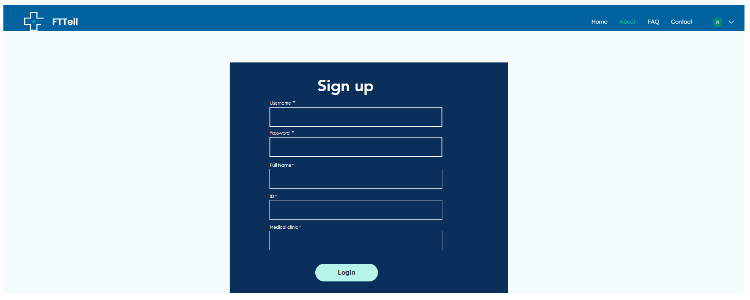

Figure 12: Sign up

**5.5 Diagrams**

5.5.1 Use Case:

The following Use Case diagram shows both the user (parents/ doctors) and Pediatrician's processes.

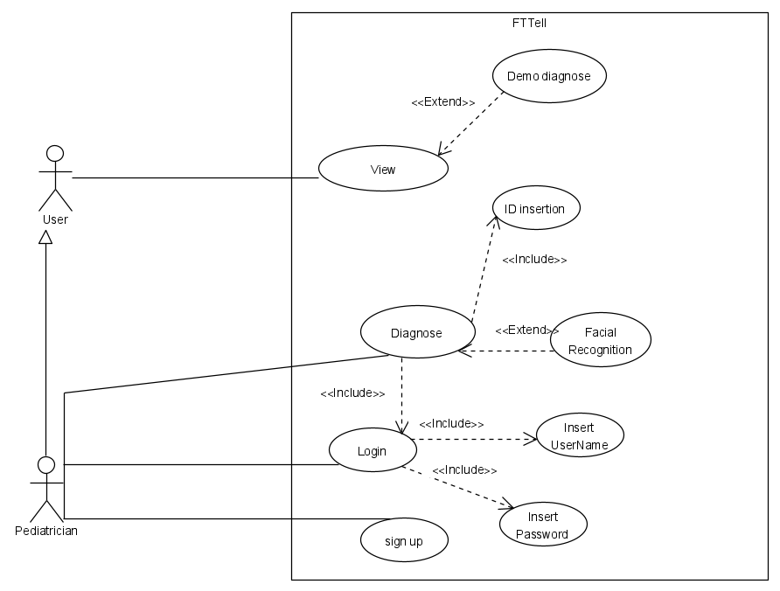

Figure 13: Use Case diagram.

5.5.2 Class:

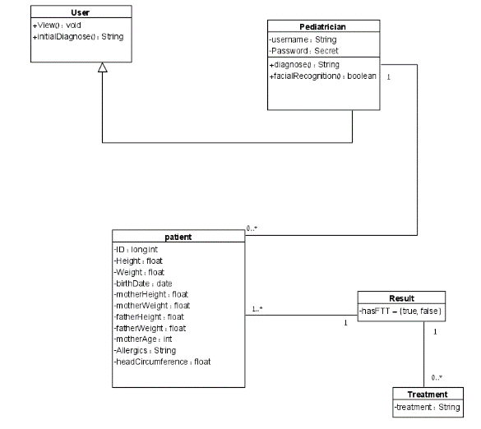

Figure 14: Class diagram

5.5.3 OPM:

* The OPM model is an extension of the diagram from article [7].

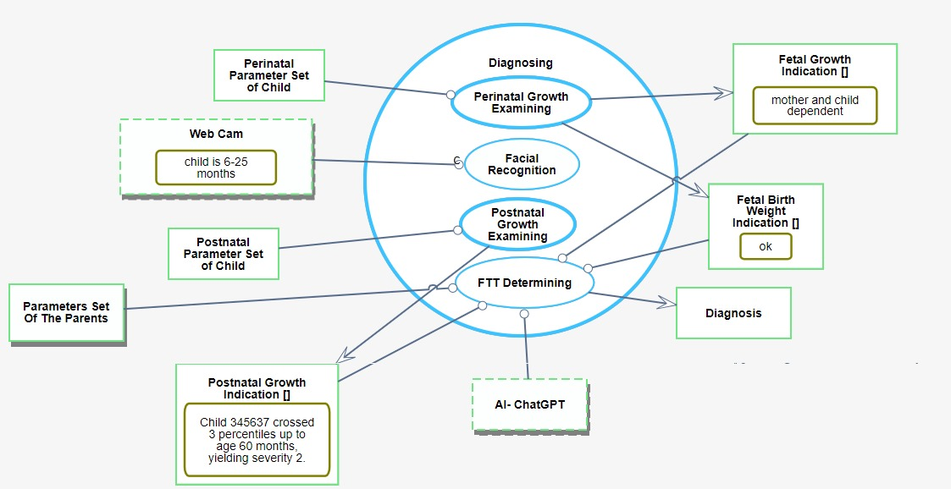

The diagram is based on a diagram from article [7].

Figure 15: OPM diagram.

1. **Verification and Evaluation**
   1. **Evaluation:**

We will evaluate our system based on the percentage of diagnostic accuracy, the diagnostic result is determined according to formula calculations that refer to the third percentile value, in addition we will consider the computer vision result (for children aged 6-25 months), the result of the initial calculations is compared to the artificial intelligence result (ChatGPT). According to these results we will build the final evaluation of the diagnosis, which leads to the calculation of the level of accuracy of the diagnosis.

Beyond the correctness of the algorithm that relies on a few elements such as formulas, inserting non-precise input by the pediatrician must be considered, the more accurate the information are the evaluation of the system will be more precise.

* 1. **Verification***:*

We will divide the testing process according to the way the system is implemented, we develop the system based on iterations, in each iteration we will implement some functionality and before we move to the next iteration we will perform a comprehensive test for everything that has already been implemented.

* Unit Testing:

For the backend (Node.js/Express.js):

Testing frameworks Jest for writing unit tests for your Node.js backend code.

Libraries like Supertest for testing HTTP endpoints.

For the computer vision components (Python): using libraries such as OpenCV.

* Integration Testing:

Ensure that the communication between frontend and backend is working correctly.

* API Testing: Testing our backend APIs independently using Postman.
* End-to-End (E2E) Testing:

For testing the application as a whole, including both frontend and backend components, we will use E2E testing frameworks, Cypress is popular choice for E2E testing.

|  |  |  |  |
| --- | --- | --- | --- |
| **Test** | **Module** | **Tested Function** | **Expected Result** |
| 1 | Data-Analysis | Receiving and decoding facial expressions | Accuracy level of receiving facial expressions |
| 2 | Data-Analysis | Classification | Accuracy<80% |
| 3 | Web-Application | Page load | First page load < 2s |
| 4 | Web-Application | Navigation | Fast page navigation |
| 5 | Web-Application | UI/UX | Up to date interface and Easy to use |
| 6 | Web-Application | Home page | Show all the page elements, all the buttons work properly and transfer the user to the right window |
| 6.1 | Web-Application | Home page-Diagnose patient button | Render the user to the diagnose page where he has to insert the patient ID, in the other case once there is no user connected it will directly open the diagnose form for demo testing. |
| 7 | Web-Application | First page in diagnosis | Checking input integrity, correct ID and pressing the button takes you to the second page in the diagnosis. |
| 7.1 | Web-Application | First page in diagnosis - Input validation | Valid input, go to the next page of the diagnosis.  Invalid input, display error message on the screen. |
| 8 | Web-Application | Form Page | Input correctness, checking the child's age and displaying the appropriate button for moving to the next step in the diagnosis. |
| 8.1 | Web-Application | Form Page-Input validation | All fields must be number except for the allergies. If the fields contain the correct values and the patient age is older than 6 month clicking next button must take the user to the next page. Otherwise he must apply. |
| 9 | Web-Application | Facial recognition page | Accurate diagnostic result according to facial expressions (Boolean value) |
| 9.1 | Web-Application | Facial recognition page-Camera | Clicking the camera icon must open the cam. |
| 9.2 | Web-Application | Facial recognition page-Camera functionality | Face recognized by the API. |
| 9.3 | Web-Application | Facial recognition  Page-recording | Ability to record the whole process. |
| 9.4 | Web-Application | Facial recognition  Page-apply button | Once the whole process ends clicking on the apply button will render the page to the final result. |
| 10 | Web-Application | Diagnosing result page | The final diagnostic result, appropriate treatment for children diagnosed with FTT |
| 10.1 | Web-Application | Diagnosing result page -Exit button | Clicking exit button, will return the application to the main page. |
| 11 | Web-Application | Login page-valid input | Pediatrician with username and password to the system has the access to the main page after clicking the login button. |
| 11.1 | Web-Application | Login page-invalid input | Incorrect input, display error message after clicking on the login button. |
| 11.2 | Web-Application | Login page – Demo button | Clicking on the demo should transfer the user to the demo test of the patient . |
| 12 | Web-Application | Data fetching from API(Postman) | Retrieve correct data from cloud storage |

**7.** **References:**

[1].Abramson, L. (1991). Facial expressivity in failure to thrive and normal infants: Implications for their capacity to engage in the world. *Merrill-Palmer Quarterly (1982-)*, 159-182.

https://www.jstor.org/stable/23087342

[2]. Byrd, R. S., Hoekelman, R. A., & Auinger, P. (1999). Adherence to AAP guidelines for well-child care under managed care. *Pediatrics*, *104*(3), 536-540. <http://pediatrics.aappublications.org/content/104/3/536>

[3]. Elice, C. E., & Fields, H. W. (1990). Failure to thrive: review of the literature, case reports, and implications for dental treatment. *Pediatr Dent*, *12*(3), 185-189.

<https://pubmed.ncbi.nlm.nih.gov/2150222/>

[4]. Homan, G. J. (2016). Failure to thrive: a practical guide. *American family physician*, *94*(4), 295-299.

<https://pubmed.ncbi.nlm.nih.gov/27548594/>

[5]. Kuczmarski, R. J. (2002). *2000 CDC growth charts for the United States: methods and development* (No. 246). Department of Health and Human Services, Centers for Disease Control and Prevention, National Center for Health Statistics.

<https://www.cdc.gov/growthcharts/background.htm>

[6]. Levi-Soskin, N., Shaoul, R., Kohen, H., Jbara, A., & Dori, D. (2019). Model-based diagnosis with FTTell: Assessing the potential for pediatric failure to thrive (FTT) during the perinatal stage. In *Information Systems: Research, Development, Applications, Education: 12th SIGSAND/PLAIS EuroSymposium 2019, Gdansk, Poland, September 19, 2019, Proceedings 12* (pp. 37-47). Springer International Publishing.

<https://incose.onlinelibrary.wiley.com/doi/10.1002/sys.21674?af=R>

[7]. Levi‐Soskin, N., Yasin, F., Dori, D., & Shaoul, R. (2023). Model‐based diagnosis with FTTell: Diagnosing early pediatric failure to thrive. *Systems Engineering*.

<https://incose.onlinelibrary.wiley.com/doi/10.1002/sys.21674?af=R>

[8]. Rowan-Legg, A., Bayoumi, I., Kwok, B., Leduc, D., Rourke, L. L., Rourke, J., & Li, P. (2021). The 2020 Rourke Baby Record release: a time for reflection and looking forward. *Paediatrics & Child Health*, *26*(5), 283-286.

<https://pubmed.ncbi.nlm.nih.gov/34336056/>

[9]. Schwartz, I. D. (2000). Failure to thrive: an old nemesis in the new millennium. *Pediatrics in review*, *21*(8), 257-264.

<https://publications.aap.org/pediatricsinreview/article-abstract/21/8/257/61629/Failure-To-Thrive-An-Old-Nemesis-in-the-New?redirectedFrom=fulltext>

[10]. GitHub Link: <https://github.com/EhsanSarboukh/Final-Project-FTT>